Task 1 :- Local Repository Setup

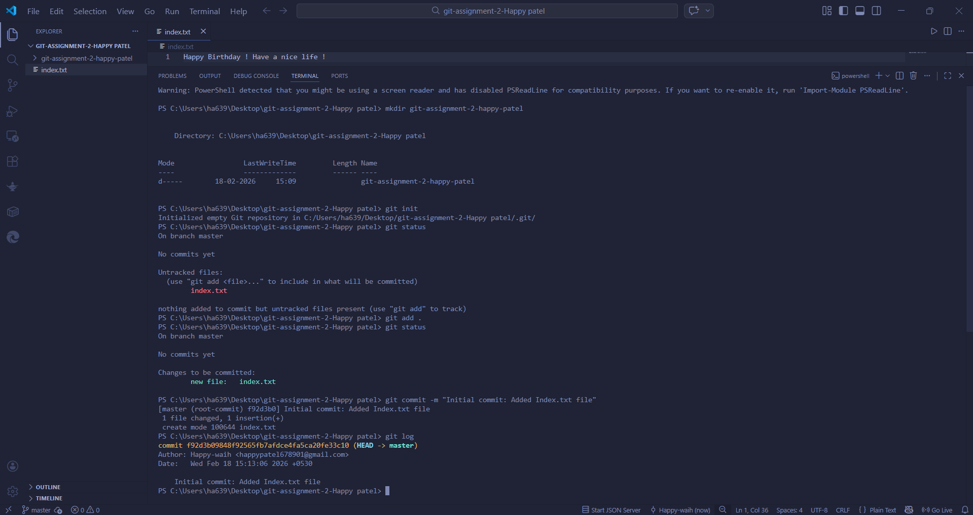

Task 2 :- Remote Repository Creation
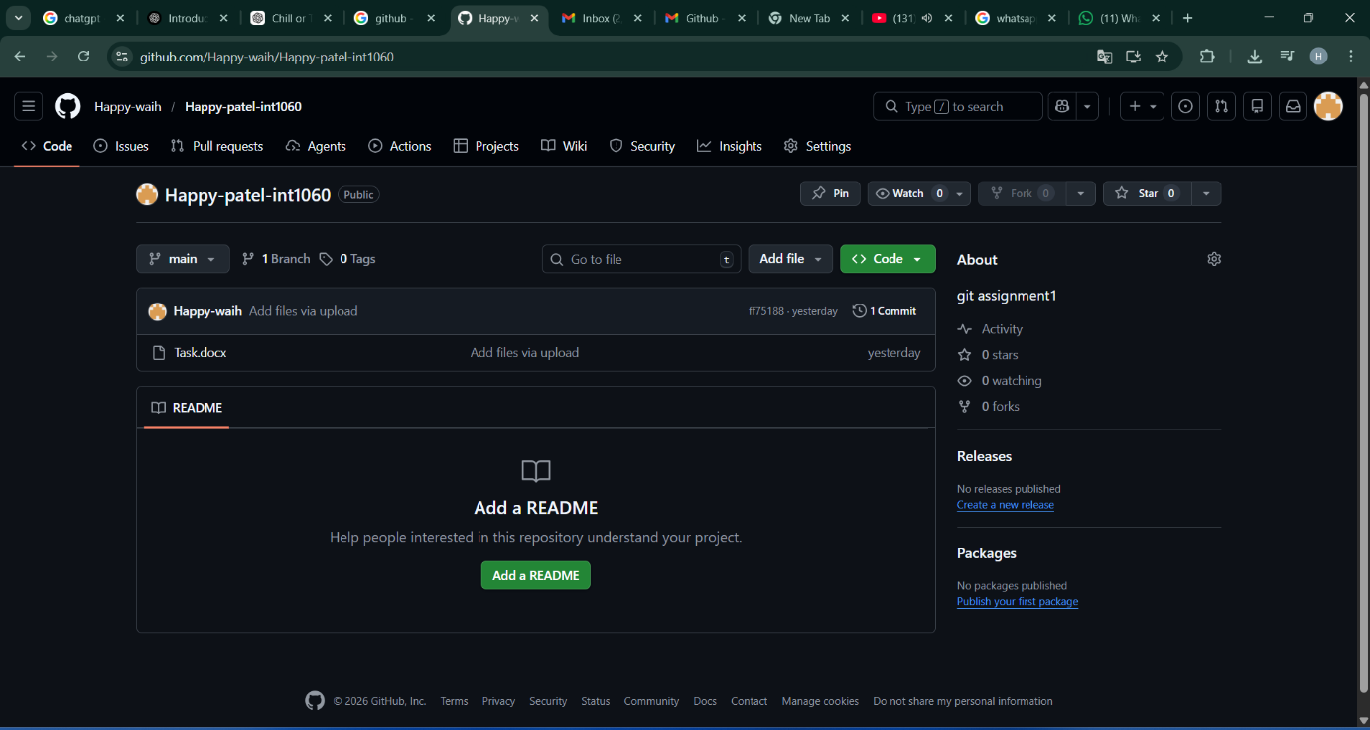

Task 3 :- Connect Local Repository to Remote
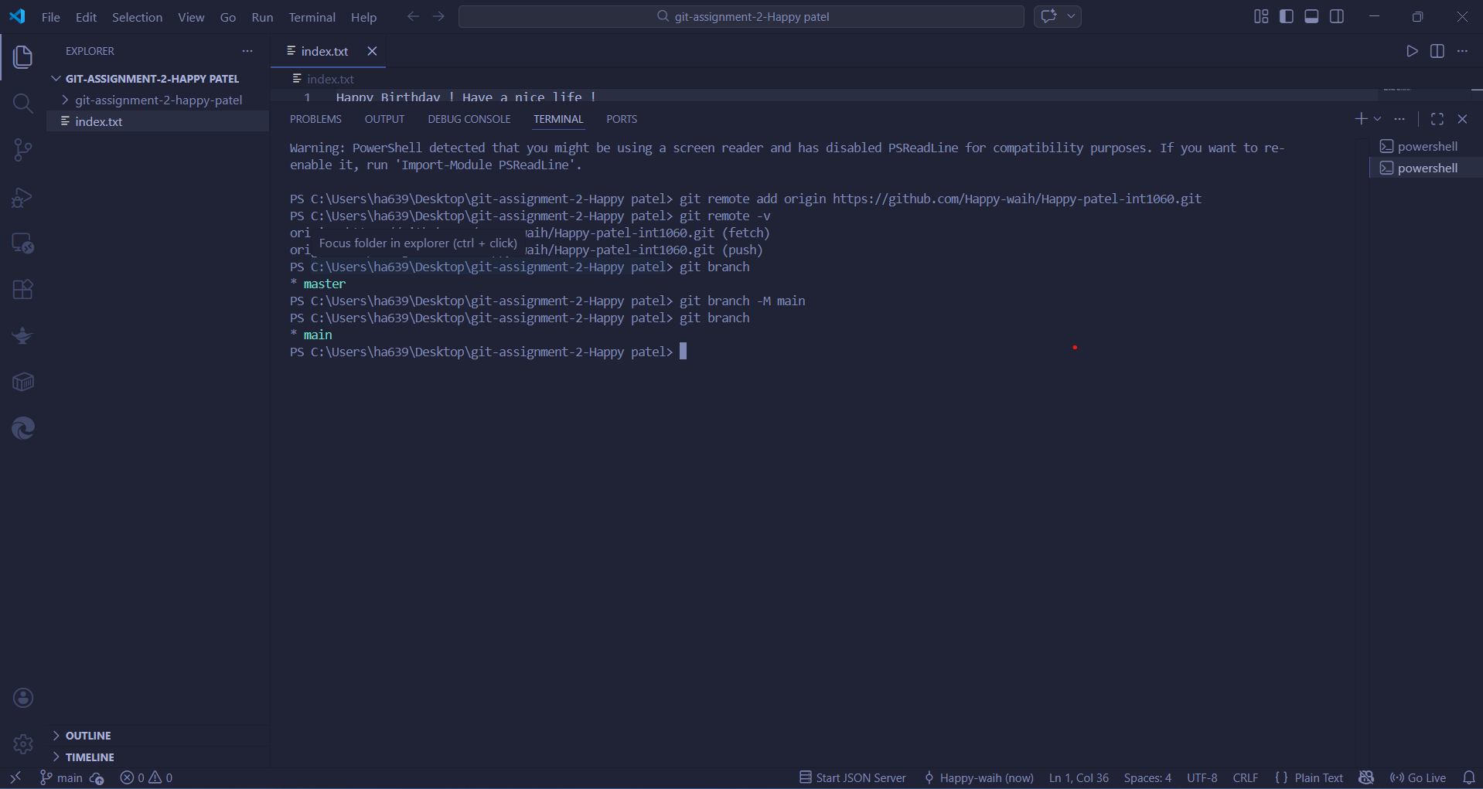

Task 4 :- Push Local Changes to Remote
Task-5 :- Branch Creation and Work
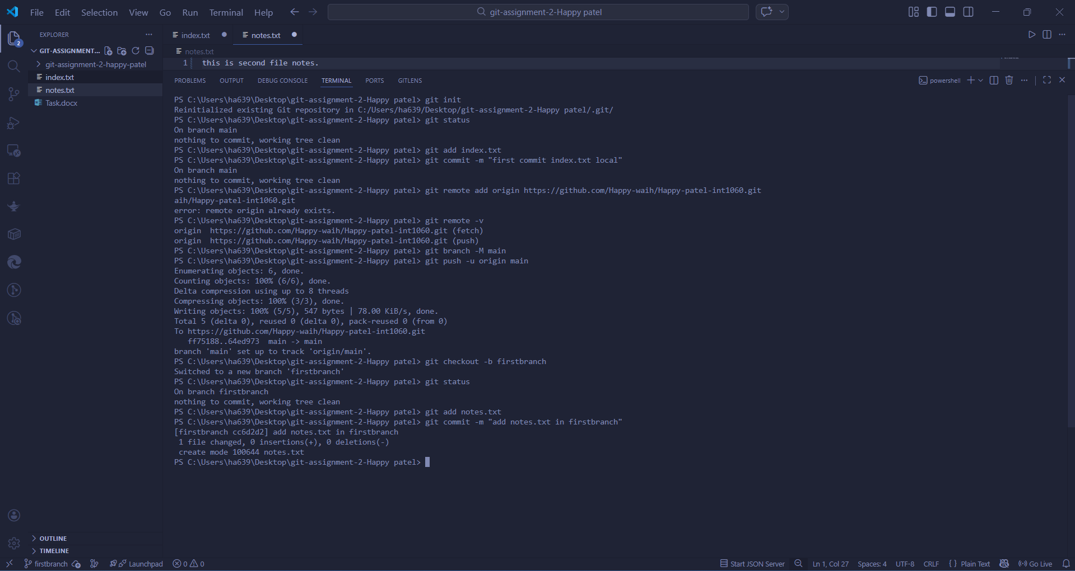

Task 6 :- Merge Branch into Main
Task 7 :- Final Sync with Remote

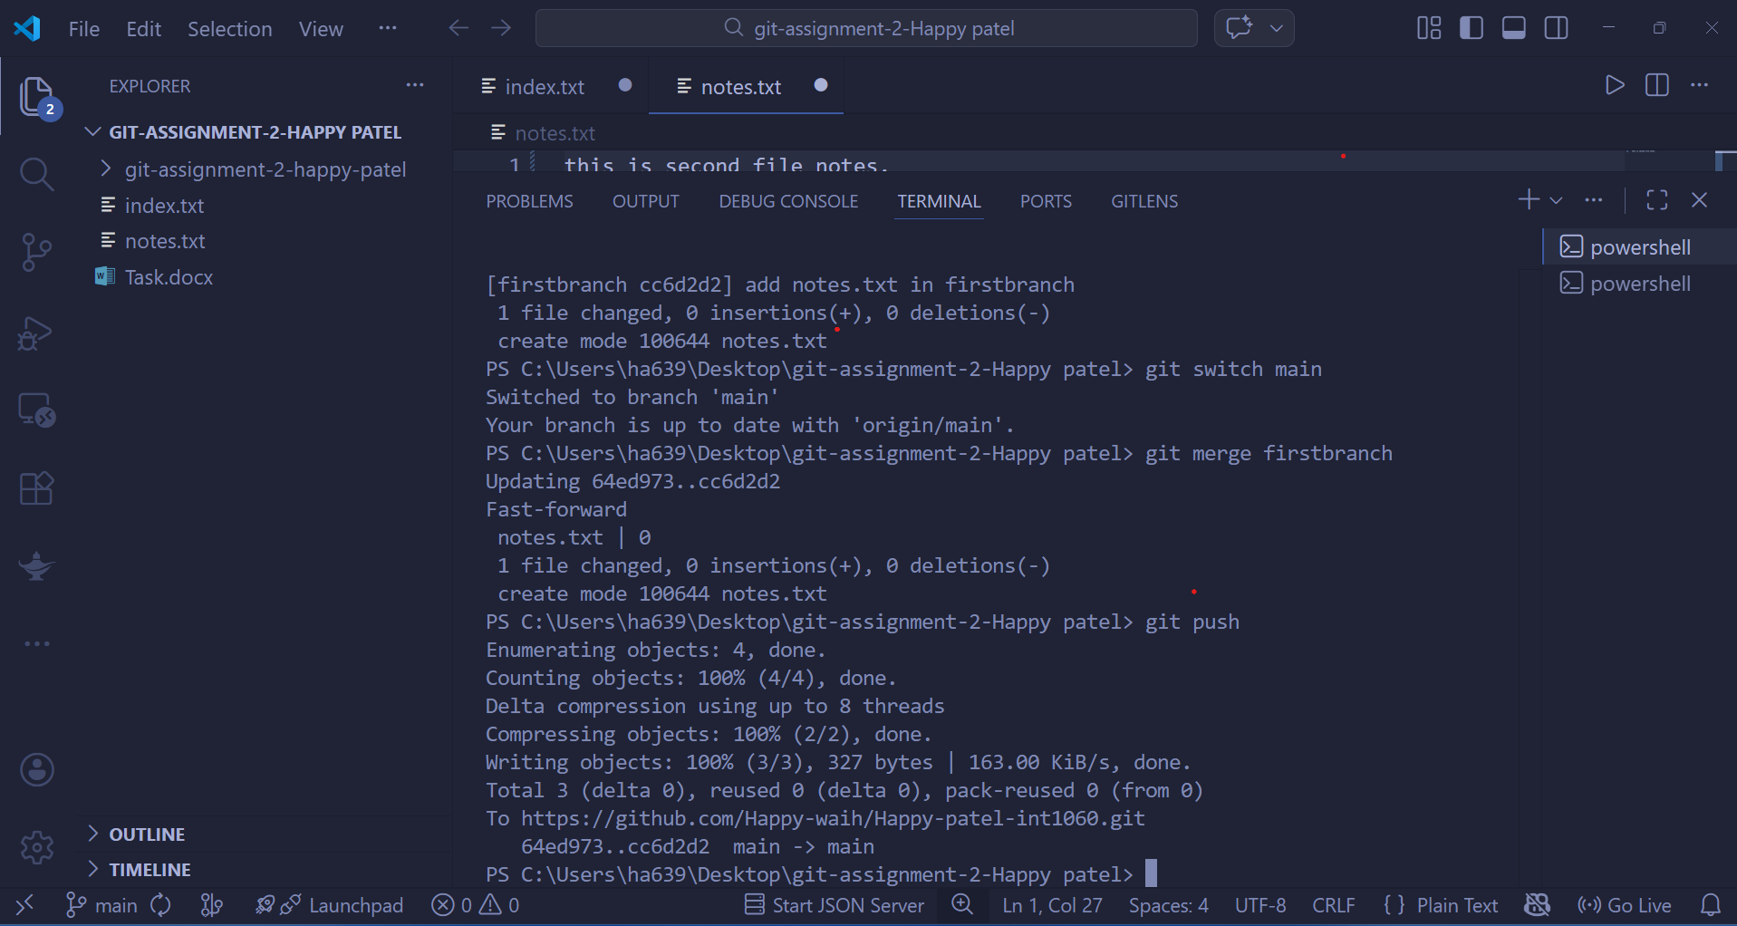

Task 8:- Simple pull
Task 9 :- Push and Pull With Conflict Resolution
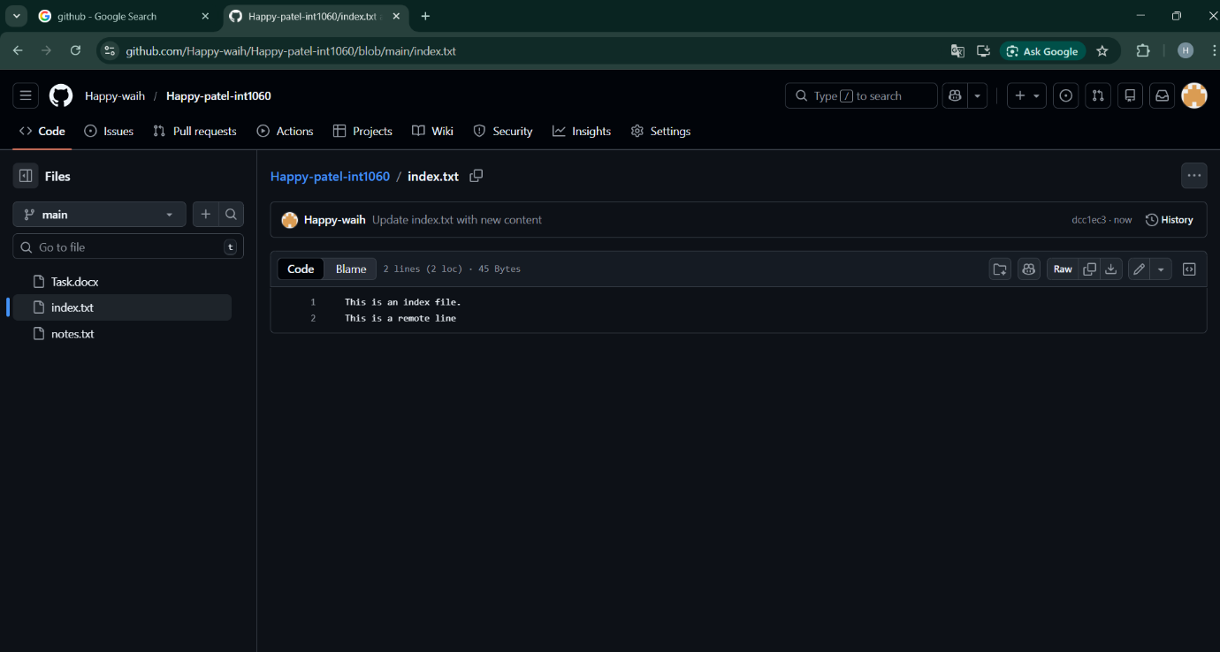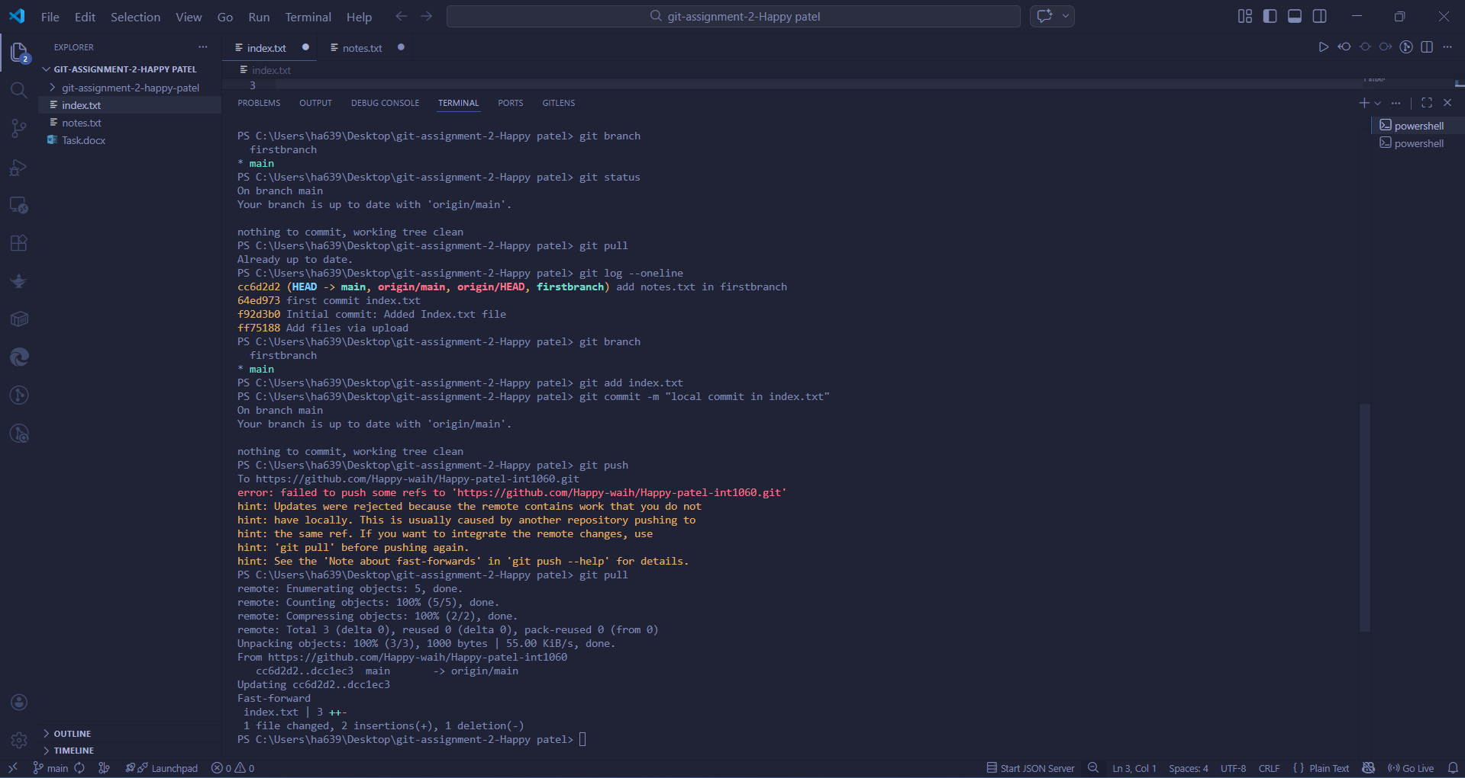

Task 10 :- Resolve merge conflict if it occurs
